Pupil premium strategy statement – Holly Lodge Girls’ College
This statement details our school’s use of pupil premium (and recovery premium) funding to help improve the attainment of our disadvantaged pupils.
It outlines our pupil premium strategy, how we intend to spend the funding in this academic year and the outcomes for disadvantaged pupils last academic year.

School overview
Detail | Data
Number of pupils in school | 1010
Proportion (%) of pupil premium eligible pupils | 50.4%
Academic year/years that our current pupil premium strategy plan covers (3 year plans are recommended – you must still publish an updated statement each academic year) | 3 years  2024/25 to 2027/28
Date this statement was published | October 2024
Date on which it will be reviewed | October 2025
Statement authorised by | Mr A Keen  (Head Teacher)
Pupil premium lead | Mrs C McGorian  (Assistant Head Teacher)
Governor / Trustee lead | Jamie Lewis (TBC)

Funding overview
Detail | Amount
Pupil premium funding allocation this academic year | £516,600
Recovery premium funding allocation this academic year  Recovery premium received in academic year 2023/24 cannot be carried forward beyond August 31, 2024. | £0
Pupil premium funding carried forward from previous years (enter £0 if not applicable) | £0
Total budget for this academic year  If your school is an academy in a trust that pools this funding, state the amount available to your school this academic year | £516,600

Part A: Pupil premium strategy plan

Statement of intent
Holly Lodge Girls’ College intention is for all of its students to be able to ‘Expect to Achieve’, irrespective of their background or the challenges they face. We aim for all students to make the best possible attainment and progress, across the curriculum so that they can successfully progress onto the next phase of their education.
Our overriding priority is to provide high quality teaching, focussed on high levels of challenge and targeted feedback, as this is proven to have the greatest impact on the attainment gap between disadvantaged students and their peers. Our goal is that disadvantaged students’ attainment and progress will be significantly improved and sustained alongside greater outcomes for their non-disadvantaged peers.
The focus of our Pupil Premium strategy is to support disadvantaged students to achieve these goals irrespective of their prior attainment at Key Stage 2, which requires a particular focus on whose are prior high achievers.
Our strategy and support activities will also:
- Consider those students deemed vulnerable, such as those who have a social worker and young carers, regardless of them being disadvantaged or not. We will consider the challenges they face and how best to ensure they are able to overcome these.
- Be integral to wider school plans for education recovery. Notably by engaging with the National Tutoring Programme for students whose education has been worst affected. This will include, where appropriate, non-disadvantaged students.
Our approach will be designed to respond to the common challenges and individual needs of disadvantages students. The approach we adopt will complement each other and support students to succeed. To ensure they are effective we will:
- adopt a whole school approach where all staff are expected to take responsibility for disadvantaged students outcomes, as well as raise their expectations of themselves and what they can achieve.
- act as early as possible to identify needs to cohorts and set appropriate intervention and support strategies
- ensure disadvantaged students are challenged in the work that they are set and receive pertinent feedback to enable them to develop further understanding and make greater progress.
- measure the impact of intervention and support strategies. Evaluate the impact made and make changes or deploy further as appropriate.

Challenges
This details the key challenges to achievement that we have identified among our disadvantaged pupils.
Challenge number | Detail of challenge
1 | Assessments on entry to year 7 in the last 5 years indicate that:  - between 23.8% – 44.5% of our disadvantaged students arrive below age-related expectations in maths which compares to 10.1% - 30.0% of their peers.  - between 23.8% – 33.9% of our disadvantaged students arrive below age-related expectations in English which compares to 7.0% - 28.6% of their peers.  While previous internal assessments show that the gap in performance widens further throughout time in our school, our 2025 GCSE Progress 8 score shows a negligible gap of 0.04.
2 | Reading age assessments for KS3 students indicate that disadvantaged students generally have lower levels of reading comprehension than peers. This impacts their progress in all subjects.  Year 7 Year 8 Year 9  PP Students  nonPP Students  On entry to year 7 in 2024, (TBC)% of our disadvantaged pupils arrive below age-related expectations compared to (TBC)% of their peers.
3 | Our attendance data for current year groups shows that attendance among disadvantaged students has been between 2% and 9% lower than for non-disadvantaged students.  Year 7 Year 8 Year 9 Year 10 Year 11  Difference 2% 6% 9% 9% 3%  Our attendance data over the last 3 years indicates that attendance among disadvantaged students has been between 4.67% - 6.74% lower than for non-disadvantaged students.  Our assessments and observations indicate that absenteeism is negatively impacting disadvantaged student progress.
4 | Our assessments (including; Blues Programme, Bounce Back Questionnaires, Oxwell Survey, Learning Mentor referrals / Sharp System notifications and MARF/EHAT requirements), observations and discussions with students and families have identified increased social and emotional issues, such as anxiety, depression (diagnosed by medical professionals) and low self-esteem. This is partly driven by concerns about catching up lost learning and exams/future prospects, and the lack of enrichment opportunities due to the pandemic. These challenges particularly affect disadvantaged students, including their attainment.
5 | Many disadvantaged students did not have access to sufficient technology to allow them to engage meaningfully in online learning during school closures. This has meant that they have fallen further behind than others during this time and beyond as they continue to struggle to access home learning. Although there has been a programme of providing technology where possible and students have always had access to paper resources it has meant they are not accessing the same content as their classmates.

Intended outcomes
This explains the outcomes we are aiming for by the end of our current strategy plan, and how we will measure whether they have been achieved.
Intended outcome | Success criteria
Improved attainment among disadvantaged students across the curriculum at the end of KS4, with a focus on EBacc subjects. | 2023/24 KS4 outcomes demonstrate that disadvantaged students achieve:  - an average Attainment 8 score of > 40.42. In the last 3 examination years this was 38.49 – 43.51  - an EBacc average point score of 3.46 per subject. In the last 3 examination years this was 3.25 – 3.69  By the end of our current plan in 2027/28, 60% or more of disadvantaged students enter the English Baccalaureate (EBacc).  In the last 3 examination years this figure was 22.5% - 56.4%.
Improved attainment among high ability disadvantaged students across the curriculum at the end of KS4, with a focus on EBacc subjects. | 2023/24 KS4 outcomes demonstrate that high ability disadvantaged students achieve:  - an average Attainment 8 score of > 57.04. In the last 3 examination years this was 52.43 – 60.13  - an EBacc average point score of 5.28 per subject.  - In the last 3 examination years this was 4.76 – 5.63  By the end of our current plan in 2027/28, 75% or more of high ability disadvantaged students enter the English Baccalaureate (EBacc). In the last 3 examination years this figure was 37.5% - 87.5%.
Improved reading comprehension among disadvantaged students across KS3. | Reading comprehension tests demonstrate improved comprehension skills among disadvantaged students and a smaller disparity between the scores of disadvantaged students and their non-disadvantaged peers. Teachers should also have recognised this improvement through engagement in lessons and book scrutiny.
To achieve and sustain improved attendance for all pupils, particularly our disadvantaged students. | Sustained high attendance from 2024/25 demonstrated by:  - the overall absence rate for all students being no more than 5.0%, and the attendance gap between disadvantaged students and their non-disadvantaged peers being reduced to no more than 5%.  - the percentage of all students who are persistently absent being below 10% and the figure among disadvantaged students being no more than 8% lower than their peers.
Continue to develop wellbeing support for vulnerable students to recover from the effects of school closures and enable them be more confident, happy and more able to engage in school and with home learning opportunities. | Students who become identified as vulnerable are able to be effectively supported both within school and by specialist agencies to be able to increasingly engage within school and maximise their attendance, attainment and progress.

Activity in this academic year
This details how we intend to spend our pupil premium (and recovery premium) funding this academic year to address the challenges listed above.

Teaching (for example, CPD, recruitment and retention)
Budgeted cost: £ 294,462
Activity | Evidence that supports this approach | Challenge number(s) addressed
Subscription to the National College to provide staff with a suite of CPD. specifically around assessing and targeting, teaching and learning and student support. | EEF Guide to the Pupil Premium—Autumn 2024 identifies High Quality Teaching as a main driver for narrowing the performance between Disadvantages Students and their peers:  EEF Guide to the Pupil Premium—Autumn 2024 | 1
Appointments of Lead Practitioners for teaching and learning. Will focus on  - development of teaching standards.  - coaching of colleagues who are identified as needing to further development.  - support for recently qualified colleagues  - delivery of the whole school reading initiative. | EEF Guide to the Pupil Premium—Autumn 2024 identifies High Quality Teaching as a main driver for narrowing the performance between Disadvantages Students and their peers:  Lead practitioners are a key appointment to drive the development of T&L standards at Holly Lodge and narrow attainment gaps.  EEF Guide to the Pupil Premium—Autumn 2024 | 1, 2
Teaching assessment and feedback development: To reinforce metacognition in teaching strategies so staff implicitly use these techniques in their day to day teaching. Staff are more aware of how students learn and can tailor lessons accordingly. Principally basing whole school routines on Rosenshein’s Principles of Instruction. | EEF Teaching toolkit:  Metacognition and Self-regulation | 1
Whole school reading initiative to students improve literacy levels and ability to comprehend written sources | Acquiring disciplinary literacy is key for students as they learn new, more complex concepts in each subject:  Improving literacy in secondary schools  Reading comprehension, vocabulary and other literacy skills are heavily linked with attainment in maths and English:  word-gap.pdf (oup.com.cn)  EEF Teaching toolkit – reading comprehension strategies | 1, 2
Purchase of IRIS Connect and StepLab subscription to support lesson observation and coaching processes for teachers who need additional support, as well as sharing of best teaching practice. | EEF Guide to the Pupil Premium—Autumn 2021 identifies High Quality Teaching as a main driver for narrowing the performance between Disadvantages Students and their peers:  EEF Guide to the Pupil Premium—Autumn 2024 | 1
Engagement with the CPD provided by the Princes Teaching Institute. These are both subject specific courses designed to support teachers to develop rich subject experience for their students and long term professional development opportunities centred on delivering exceptional teaching and transformational classroom practices | EEF Guide to the Pupil Premium—Autumn 2024 identifies High Quality Teaching as a main driver for narrowing the performance between Disadvantages Students and their peers:  EEF Guide to the Pupil Premium—Autumn 2024 | 1
Additional learning resources targeted towards teachers being able to support disadvantaged students for whom the school closures meant they were unable to make the progress their peers did. | EEF Guide to the Pupil Premium—Autumn 2024 identifies High Quality Teaching as a main driver for narrowing the performance between Disadvantages Students and their peers:  EEF Guide to the Pupil Premium—Autumn 2024 | 1

Targeted academic support (for example, tutoring, one-to-one support, structured interventions)
Budgeted cost: £ 92,988
Activity | Evidence that supports this approach | Challenge number(s) addressed
Employ and train a qualified teacher to deliver Lexonic programs to red readers. | Tuition targeted at specific needs and knowledge gaps can be an effective method to support low attaining students or those falling behind, both one-to-one and in small groups:  EEF Teaching toolkit – one to one tuition | 1, 2, 3
Teaching assistants, small group and one to one intervention for students requiring the greatest support | Teaching assistants deployed in two ways; to support the teacher in the general classroom environment, or to provide targeted interventions, which are often delivered out-of-class.  EEF Teaching toolkit – Teaching assistant interventions | 1, 2
Summer school  Allowing new year 6 students to arrive ready and prepared to start HL in September | Transition programme focused on literacy, numeracy and wellbeing  EEF Teaching toolkit –  Summer schools | 1, 2, 4, 5
Debate Mate- to enhance students’ confidence and self-esteem through oracy. | Opportunity for students to develop key analysis and debating skills. Develop key Oracy.  EEF Teaching toolkit – Oral Language interventions | 2
A range of intervention activities designed to improve the outcomes of key year 11 students. In particular in English, Maths and Science. | A number of EEF teaching toolkit intervention activities , including:  Extending school time  Mentoring  Small group  Tuition  Homework | 1, 2, 3

Wider strategies (for example, related to attendance, behaviour, wellbeing)
Budgeted cost: £ 129,150
Activity | Evidence that supports this approach | Challenge number(s) addressed
Enhanced pastoral support due to needs of student cohort with high level of disadvantage. Including non-teaching year leaders and learning mentors. | Increased in school capacity to support students with well-being and social emotional issues which are acknowledged as having a significant impact upon their ability to achieve in school.  EEF Teaching toolkit – Mentoring  Public Heath England Advice – The link between pupil health and wellbeing and attainment | 4, 5
Transform project | Youth Sports Trust target support for physical and mental wellbeing through physical activity, working with Year 10 students.  Place 2 Be-Staff CPD to identify and support students with mental health issues. Student support on Yr 7 and 8.  Debate Mate- to enhance students’ confidence and self-esteem through oracy.  Public Heath England Advice – The link between pupil health and wellbeing and attainment | 4, 5
Increasing Parental engagement | Numeracy booklet launched to “explain new mathematical methods to parents “numeracy activities for parents and students to do together.  School cloud software purchase renewed to allow virtual parents evening events to increase parental engagement.  Planned purchase of App solution to allow parents access to key school information such as attendance, reports and behaviour incidents  Deloitte parent workshop.  EEF Teaching toolkit – Parental Engagement | 1, 2, 3, 4, 5, 6

Total budgeted cost: £ 516,600

Part B: Review of the previous academic year

Outcomes for disadvantaged pupils
Outcomes for disadvantaged students have been constantly improving at Holly Lodge in line with the improved performance of the school overall. The 2024 disadvantaged cohort were the most successful to date, as demonstrated by the chart of Progress 8 performance shown below:
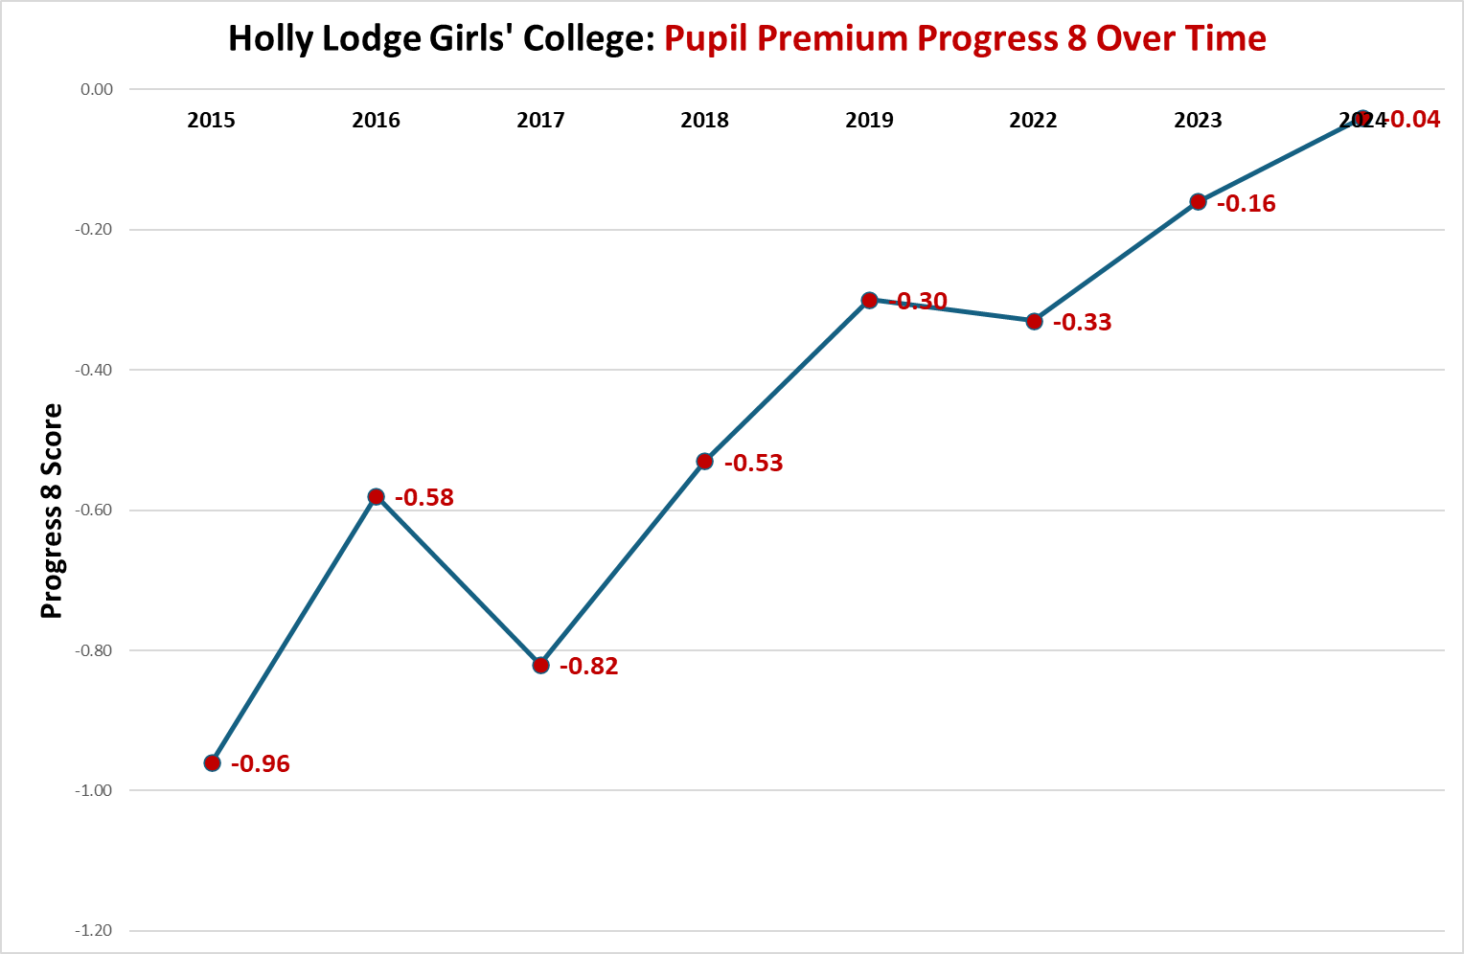
Figure 1: Disadvantaged Student P8 over time (excludes Covid-19 effected years)
In addition to increased progress being produced started by disadvantaged students, there is a trend of increased attainment from the same cohort. Attainment 8 has rise over the same period, as can be seen below:
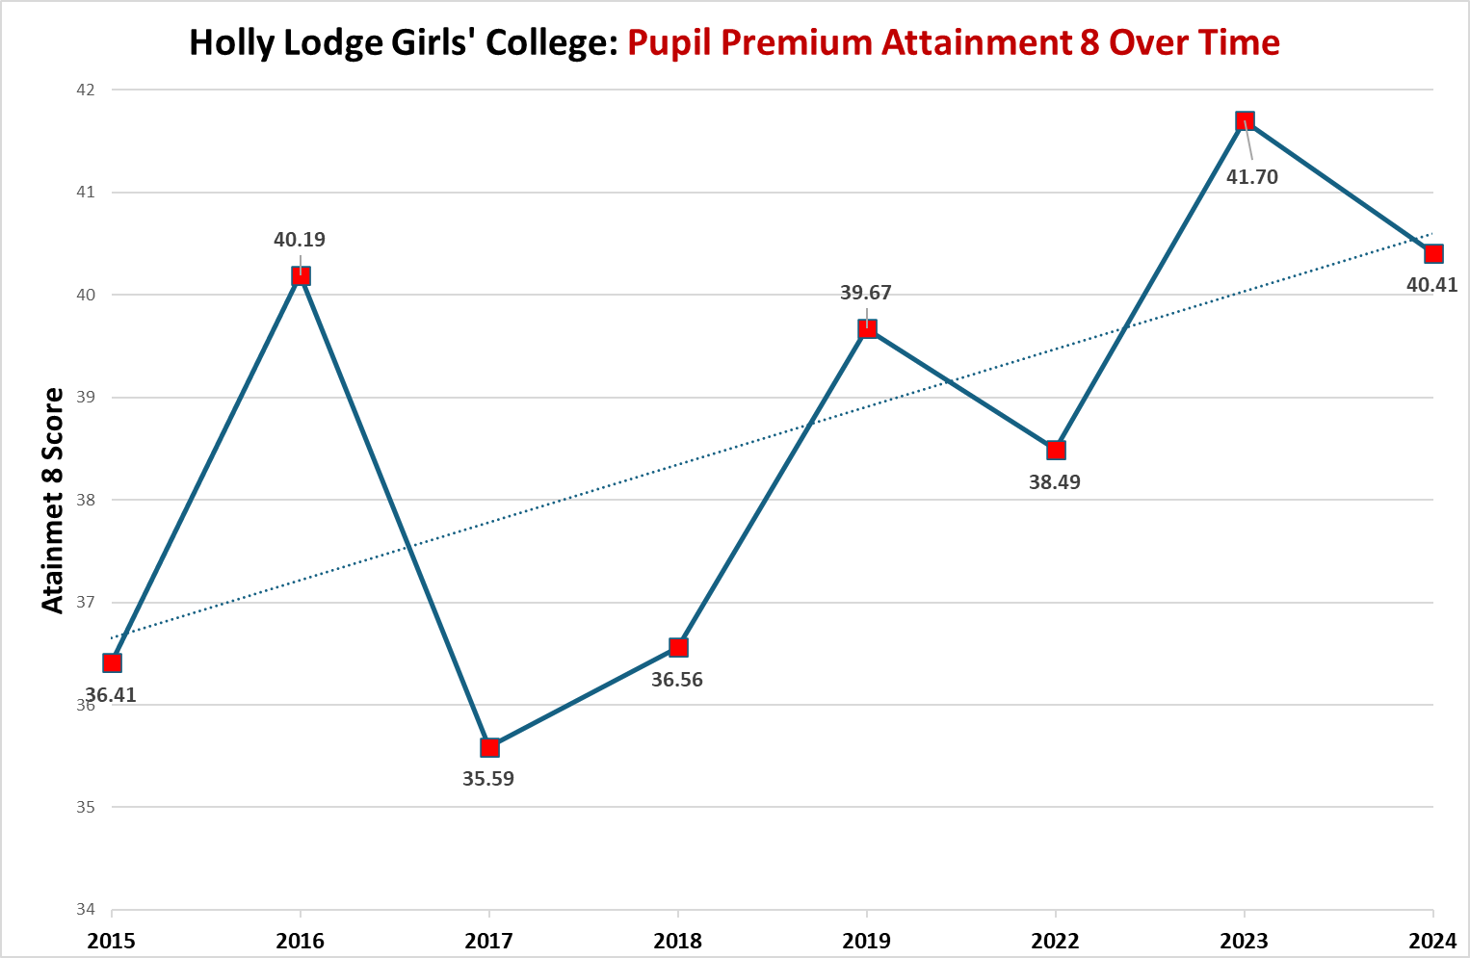
Figure 2: Disadvantaged Students A8 over time (excludes Covid-19 effected years)

English Baccalaureate:
Since 2017 the percentage of disadvantaged students accessing the full EBacc quite of qualifications has risen considerably. This can be seen below:
Year | 2017 | 2018 | 2019 | 2022 | 2023 | 2024
% Disadvantaged cohort taking Ebacc | 17.6% | 24.6% | 33.8% | 24.7% | 56.4% | 47.0%

Over the same period the Average Point score for each Ebacc qualification slot that has been generated by Disadvantaged Students has grown, as shown below:
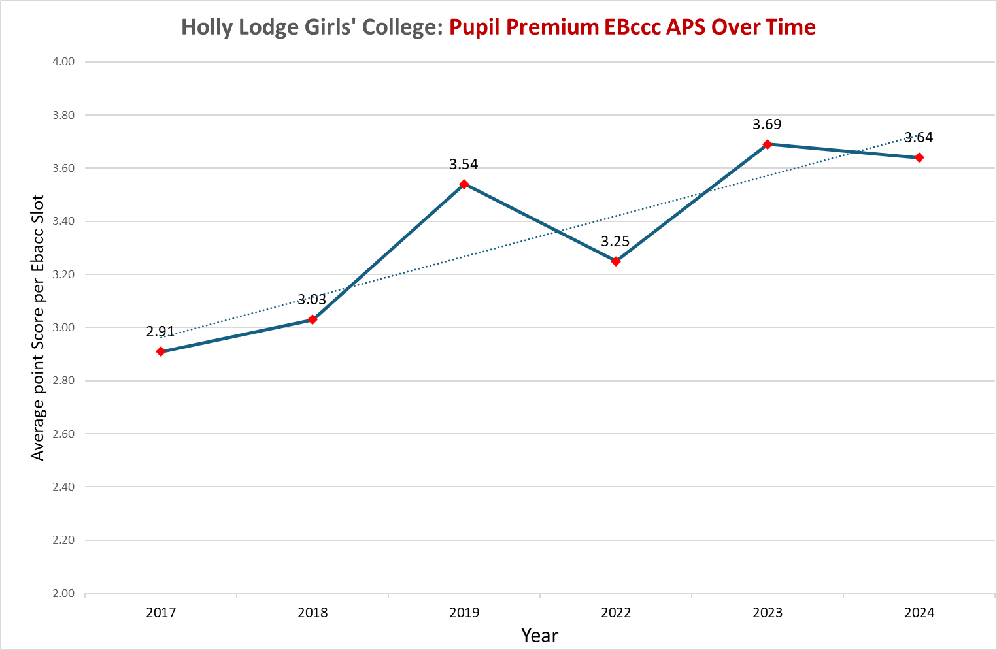
Figure 3: Disadvantaged students Ebacc APS
Aligned with this progress the percentage of disadvantaged students passing the English Baccalaureate in each qualification at both 5+ (Strong Pass) and 4+ (standard pass) have increased. As shown below:
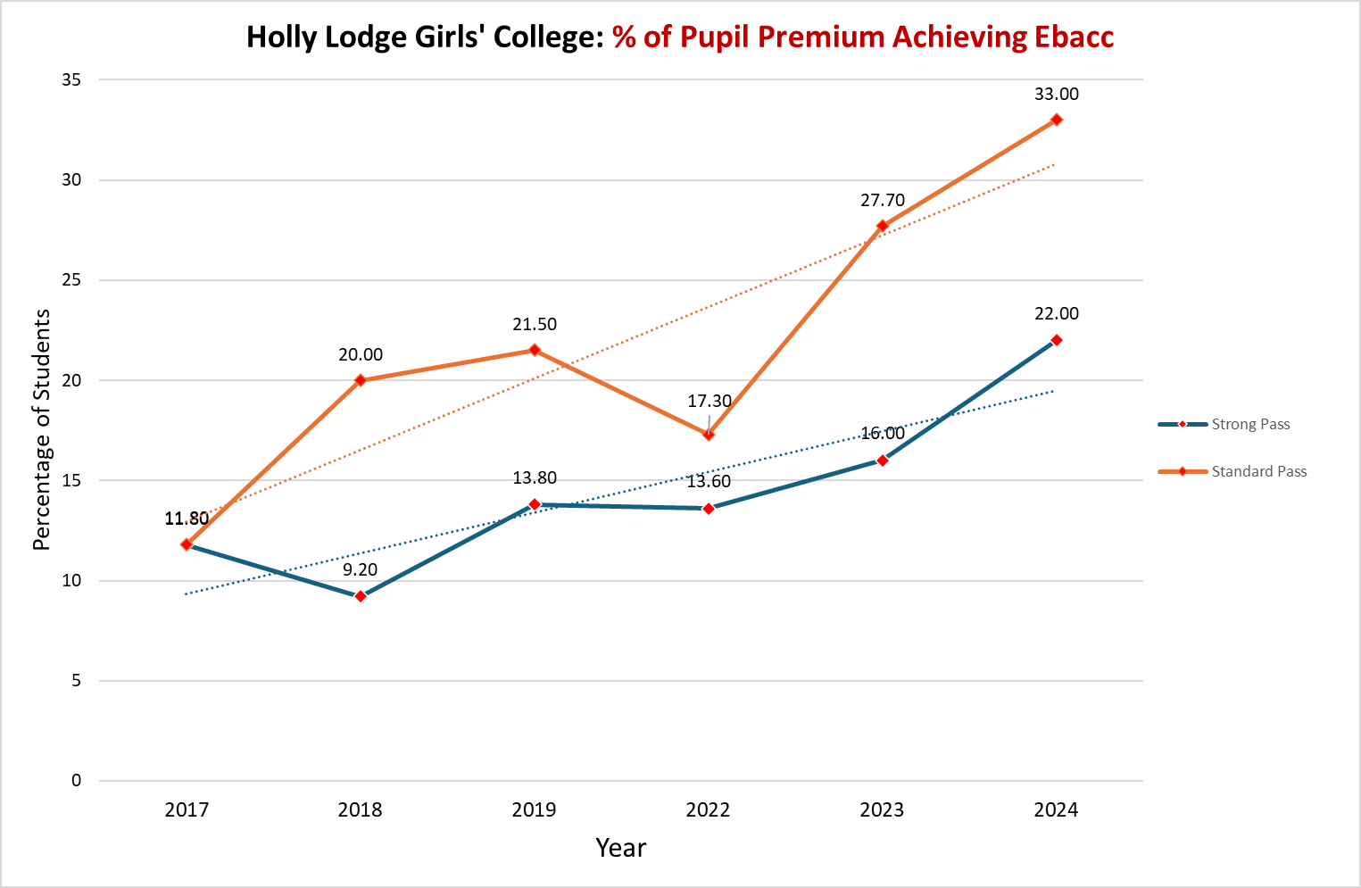
Figure 4: Disadvantaged Students % Ebacc Pass

Performance compared to non-disadvantaged students:
Students’ outcomes in 2024 for disadvantaged students at Key Stage 4 showed little difference in the progress made from Key Stage 2 when they are compared to their non-disadvantaged peers. The Overall Progress 8 Score, plus that generated in the separate elements of the calculation are shown below:
Measure: | Disadvantaged Students | Non-Disadvantaged Students | Gap
Overall Progress 8 | -0.04 | 0.01 | -0.05
English Progress 8 | -0.07 | 0.32 | -0.39
Maths Progress 8 | -0.02 | 0.03 | -0.05
Ebacc Progress 8 | -0.12 | -0.23 | +0.11
Open Progress 8 | -0.06 | 0.02 | -0.08

Externally provided programmes
Please include the names of any non-DfE programmes that you used your pupil premium (or recovery premium) to fund in the previous academic year.
Programme | Provider
Mentoring from a network of professional female role models | Girls’ Network
Liverpool Hope University | Hope Opportunity Trust
Inspire and Reaching Higher | Aspire Liverpool
Academic conference | Rugby School

Service pupil premium funding (optional)
For schools that receive this funding, you may wish to provide the following information: How our service pupil premium allocation was spent last academic year
n/a
The impact of that spending on service pupil premium eligible pupils
n/a

Further information (optional)
Our pupil premium strategy will be supplemented by additional activity that is not being funded by pupil premium or recovery premium. That will include:
- offering a wide range of high-quality extracurricular activities to boost wellbeing, behaviour, attendance, and aspiration. Activities (e.g., The Duke of Edinburgh’s Award), will focus on building life skills such as confidence, resilience, and socialising. Disadvantaged students will be encouraged and supported to participate.
- A range of aspiration activities which have been developed with high quality partners such as The Girls Network and the Hope Opportunity Trust. Which provide access to support programmes and Further Education opportunities which can be sued to further inspire Disadvantaged students to engage with their academic studies.
- Continuing to embed more effective practice around questioning and feedback. EEF evidence demonstrates this has significant benefits for students, particularly disadvantaged students
Planning, implementation, and evaluation:
In planning our new pupil premium strategy, we evaluated activities undertaken in previous years and reviewed the degree of impact that they expected. We also engage with a Local Authority working part which is targeted to sharing best practice in supporting disadvantaged students.
We triangulated evidence from multiple sources of data including assessments, learning walks demonstrating engagement in class, book scrutiny, and conversations with parents, students & teachers in order to identify the challenges faced by disadvantaged students.
We looked at a number of reports and studies about effective use of pupil premium, the impact of disadvantage on education outcomes and how to address challenges to learning presented by socio-economic disadvantage. We also looked at a number of studies about the impact of the pandemic on disadvantaged students, in particular their well-being.
We used the EEF’s implementation guidance to help us develop our strategy and will continue to use it through the implementation of our activities.
We have put a robust evaluation framework in place for the duration of our three-year approach, including oversight from out governing body and will adjust our plan over time to secure better outcomes for students.

